CSA6303 - THREAT INTELLIGENCE AND NETWORK SECUR
Assessment Tool 1: CONCEPT MAPPING
Faculty : Dr.V.Parthipan SLOT A

Topics: Network Security Fundamentals | Security Goals (CIA Triad) | Types of Network Threats |Introduction to Threat Intelligence Types of Threat Intelligence (Strategic, Tactical, perational) — Threat Intelligence Lifecycle — Applications in IT Industry
CO1: Interpret security principles, network threats, and the role of threat intelligence in cybersecurity.

Total: 50
Student Name : Surya V Register number: 192465018

Code of Conduct:

I Surya V/192465018 (Name / Reg No) certify that this submission is my original work and that I have adhered to the guidelines specified for this assessment. I understand that any violation of academic integrity rules will result in disciplinary action.


Signature of the student

CO1 – Concept Mapping Questions
No. | Concept-Mapping Question
1 | Construct a comprehensive concept map explaining the foundations of Network Security. Connect network security fundamentals with security objectives, the CIA Triad (Confidentiality, Integrity, and Availability), network assets, vulnerabilities, threats, and protective measures, and explain how these concepts collectively support secure network operations.
2 | Develop a concept map illustrating the CIA Triad as the foundation of network security. Relate Confidentiality, Integrity, and Availability to different types of network threats and demonstrate how a single threat can affect one or more security goals.
3 | Construct a concept map classifying different types of Network Threats and their potential impact on security goals. Connect threats such as malware, phishing, denial-of-service, spoofing, eavesdropping, and unauthorized access with the CIA Triad and explain the resulting security implications.
4 | Develop an integrated concept map connecting Network Security Fundamentals, Network Threats, and Threat Intelligence. Show how identifying assets, vulnerabilities, and threats leads to the collection and analysis of threat information and ultimately supports informed security decisions.
5 | Construct a concept map explaining the concept of Threat Intelligence and its role in modern network security. Relate threat actors, indicators, vulnerabilities, attack patterns, threat information, analysis, and actionable intelligence to demonstrate how Threat Intelligence helps organizations anticipate and respond to network threats.
6 | Develop a comparative concept map of Strategic, Tactical, and Operational Threat Intelligence. Connect each type with its purpose, target audience, time horizon, information requirements, decision-making process, and appropriate network-security use cases, and analyze how the three intelligence types complement one another.
7 | Construct a concept map representing the complete Threat Intelligence Lifecycle. Connect planning/direction, collection, processing, analysis, dissemination, and feedback with the identification of network threats and security requirements, showing how feedback continuously improves the intelligence process.
8 | Develop an end-to-end concept map showing how a network threat progresses from identification to actionable Threat Intelligence. Connect network security fundamentals, CIA security goals, threat detection, intelligence collection, processing, analysis, dissemination, and response, and explain the relationship between each stage.
9 | Create a scenario-based concept map for an organization experiencing a major network attack. Integrate the CIA Triad, types of network threats, Strategic Intelligence, Tactical Intelligence, Operational Intelligence, and the Threat Intelligence Lifecycle to demonstrate how the organization can understand, prioritize, and respond to the threat.
10 | Design a comprehensive concept map demonstrating the applications of Network Security and Threat Intelligence in the IT industry. Connect network security fundamentals, CIA Triad, network threats, Threat Intelligence, Strategic/Tactical/Operational Intelligence, and the Threat Intelligence Lifecycle with applications such as threat monitoring, incident response, vulnerability management, risk assessment, security operations, and organizational decision-making.

Construct a concept map classifying different types of Network Threats and their potential impact on security goals. Connect threats such as malware, phishing, denial-of-service, spoofing, eavesdropping, and unauthorized access with the CIA Triad and explain the resulting security implications.
Concept Map 3: Network Threats and Their Impact on the CIA Triad
3.1 Overview
The CIA Triad defines the three core security goals of any network:
- Confidentiality: only authorized parties can read the data.
- Integrity: data and systems are not altered without authorization.
- Availability: systems and data are accessible when needed.
Every network threat attacks one or more of these goals. The map below links each threat to the goal(s) it damages.
3.2 Concept Map
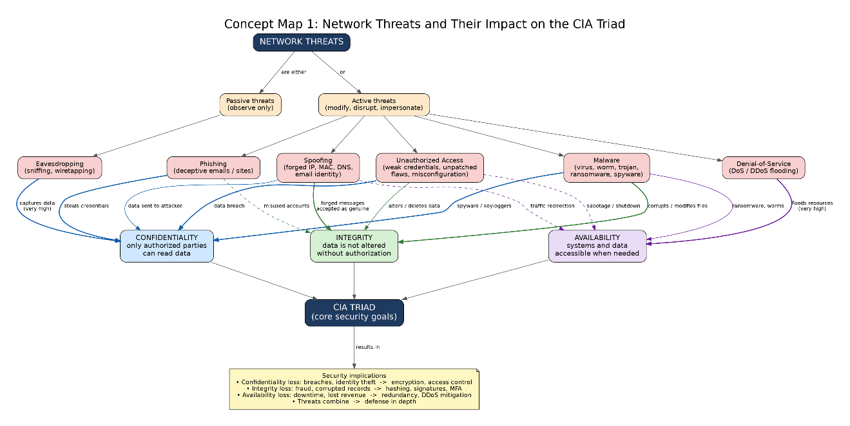
Figure 1: Network threats and their impact on the CIA Triad

3.3 Threat-to-Goal Linkage Table
Threat | How it works | Confidentiality | Integrity | Availability | Resulting security implication
Malware | Malicious code (virus, worm, trojan, ransomware, spyware) runs on a host | High (spyware, keyloggers steal data) | High (modifies or corrupts files) | High (ransomware locks data, worms consume bandwidth) | Full system compromise, data theft, data loss, financial and recovery cost
Phishing | Fake emails or sites trick users into revealing credentials or running malware | High (credentials and personal data leaked) | Medium (accounts misused to alter data) | Low | Gateway to account takeover, fraud, and further attacks; exploits human weakness
Denial-of-Service (DoS/DDoS) | Flooding a server or link with traffic or requests | None | None | Very high | Service outage, lost business and trust; often used as a smokescreen for other attacks
Spoofing | Forging IP, MAC, DNS, or email identity to pose as a trusted entity | High (victims send data to the attacker) | High (forged messages accepted as genuine) | Medium (e.g., ARP/DNS spoofing redirects traffic) | Authentication is defeated; enables man-in-the-middle and session hijacking
Eavesdropping (Sniffing) | Passive capture of packets on the network | Very high | Low (passive only) | None | Silent data leakage, hard to detect; exposes plaintext credentials and sensitive data
Unauthorized Access | Entering systems through weak passwords, unpatched flaws, or misconfigurations | Very high | High (data can be modified or deleted) | Medium (systems can be shut down or sabotaged) | Breach of data, privilege escalation, and a foothold for persistent attacks
3.4 Active vs. Passive Classification
- Passive threats (observe only; target Confidentiality): eavesdropping / sniffing, traffic analysis.
- Active threats (modify, disrupt, or impersonate; target Integrity and Availability): malware, denial-of-service, spoofing, phishing (social engineering), unauthorized access.
3.5 Security Implications
- Confidentiality loss leads to data breaches, identity theft, regulatory penalties, and reputation damage. Countermeasures: encryption (TLS, VPN), access control, DLP.
- Integrity loss leads to corrupted records, fraudulent transactions, and untrustworthy systems. Countermeasures: hashing, digital signatures, checksums, change monitoring, secure authentication.
- Availability loss leads to downtime, lost revenue, and disrupted critical services. Countermeasures: redundancy, load balancing, rate limiting, DDoS mitigation, backups.
- Threats combine. Phishing often delivers malware, which gives unauthorized access, which enables eavesdropping or data tampering. Defense therefore needs layers (defense in depth) rather than a single control.
3.6 Threat-to-Control Summary
Threat | Primary controls
Malware | Antivirus/EDR, patching, application whitelisting, email filtering
Phishing | User awareness training, email filters, multi-factor authentication
DoS/DDoS | Firewalls, rate limiting, CDN/scrubbing services, redundancy
Spoofing | Ingress/egress filtering, DNSSEC, ARP inspection, mutual authentication
Eavesdropping | Encryption (TLS, IPsec, VPN), switched networks, secure Wi-Fi
Unauthorized access | Strong passwords, MFA, least privilege, IDS/IPS, patch management

Develop an integrated concept map connecting Network Security Fundamentals, Network Threats, and Threat Intelligence. Show how identifying assets, vulnerabilities, and threats leads to the collection and analysis of threat information and ultimately supports informed security decisions.
Concept Map 4: Integrated Map of Network Security Fundamentals, Network Threats and Threat Intelligence
4.1 Overview
This map shows how the three areas form one continuous cycle. Security fundamentals tell us what to protect and why; threat knowledge tells us what can go wrong; threat intelligence turns raw information into decisions.
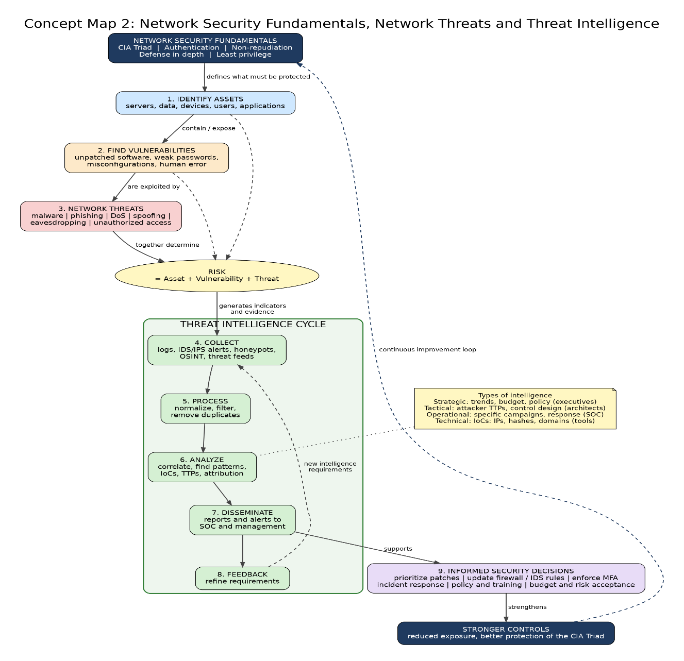
4.2 Integrated Concept Map
Figure 2: Integrated map of security fundamentals, threats and threat intelligence
4.3 Linking Propositions (How the Concepts Connect)
From | Relationship | To
Security fundamentals (CIA Triad) | defines what must be protected | Assets
Assets | contain or expose | Vulnerabilities
Vulnerabilities | are exploited by | Threats (via threat actors and attack vectors)
Asset + Vulnerability + Threat | together determine | Risk
Threats | leave behind | Indicators of Compromise (logs, alerts, traffic anomalies)
Indicators and external sources | are gathered during | Collection
Collected raw data | becomes information after | Processing
Information | becomes intelligence after | Analysis (context, relevance, attribution)
Intelligence | is shared through | Dissemination to analysts, SOC, and management
Intelligence | supports | Security decisions
Security decisions | improve | Controls, which protect the CIA Triad
Results of decisions | feed back into | Collection requirements and asset/vulnerability review
4.4 Types of Threat Intelligence in the Map
Level | Audience | Content | Decision supported
Strategic | Executives, management | Trends, threat landscape, attacker motives, industry risks | Budget, risk strategy, policy
Tactical | Security architects, defenders | Attacker tactics, techniques and procedures (TTPs) | Control design, detection rules
Operational | Incident responders, SOC | Details of specific campaigns and attacks | Response planning, hunting
Technical | Analysts, security tools | IoCs: IP addresses, domains, file hashes, URLs | Blocking, alerting, SIEM/IDS signatures
4.5 Worked Example Through the Map
- Asset identified: the company web server holding customer data (Confidentiality and Availability matter most).
- Vulnerability found: an unpatched web application component and an admin account with a weak password.
- Threat: attackers use phishing to steal credentials, then gain unauthorized access, and a DDoS attack is launched as a distraction.
- Collect: firewall logs, IDS alerts, a threat feed listing the attacker's IP ranges, and phishing reports from employees.
- Process and analyze: logs are normalized and correlated; the analysis shows the same IP range and phishing domain match a known campaign targeting this industry.
- Disseminate: the SOC receives IoCs; management receives a summary of the campaign's risk.
- Decision: patch the component immediately, block the malicious IPs and domains, enforce MFA, run phishing awareness training, and add DDoS protection.
- Feedback: after the incident, the team updates its asset inventory and intelligence requirements.
4.6 Key Takeaways
- Security begins with knowing what to protect (assets) and where it is weak (vulnerabilities).
- Threats are the actors and actions that exploit those weaknesses, and each one maps to a CIA goal.
- Threat intelligence converts raw data into context-rich knowledge through collection, processing, analysis, and dissemination.
- That knowledge enables proactive, prioritized, evidence-based decisions rather than reactive ones.
- The process is a continuous loop: decisions strengthen fundamentals, and new incidents produce new intelligence.

